The University of Miami Urban Studies Program
and the School of Architecture
present a lecture by

Robert C. Kloosterman

Architecture as Cultural Industry:
The Case of Rotterdam

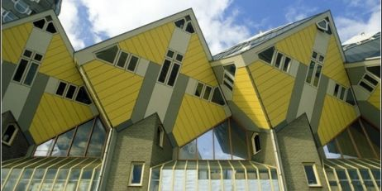

Monday, November 3, 2008
6:00 p.m. Refreshments, 6:30 p.m. Lecture
Jorge M. Perez Architecture Center Glasgow Hall, School of Architecture
1223 Dickinson Drive, University of Miami Coral Gables Campus

Robert Kloosterman is Professor of Geography and Director of Metropolitan and International Development Studies at the University of Amsterdam. He is one of the leading European researchers on cultural industries and their role in urban development. Recent books include Immigrant Entrepreneurs: Venturing Abroad in the Age of Globalization (2003) and Learning from Clusters: Economic-Geographical Perspectives (2005). He is currently finishing a book on the architectural industrial clusters and practices in the Netherlands.

The closing decade of the 20th century witnessed the remarkable emergence and rise to fame of architecture and design firms in the Netherlands, especially in Rotterdam (e.g., Wanders, Eek, Jongerius, Koolhaas, MVRDV, West 8, etc.). The lecture will focus on Rotterdam’s specific local culture, on the ‘unique’ role of Rem Koolhaas as a change agent, and more generally on the dynamics of the architectural clusters and practices with their particular labor relations and tradition of spin-offs.

This lecture is free and open to the public. Parking is available in the Pavia Garage one block from the entrance to the University on Stanford Drive. For more information and directions,
please visit www.arc.miami.edu or call 305-284-5002.

